LAB TASK 02

LEARNIX E-Learning Website

**Use Case Diagram:**

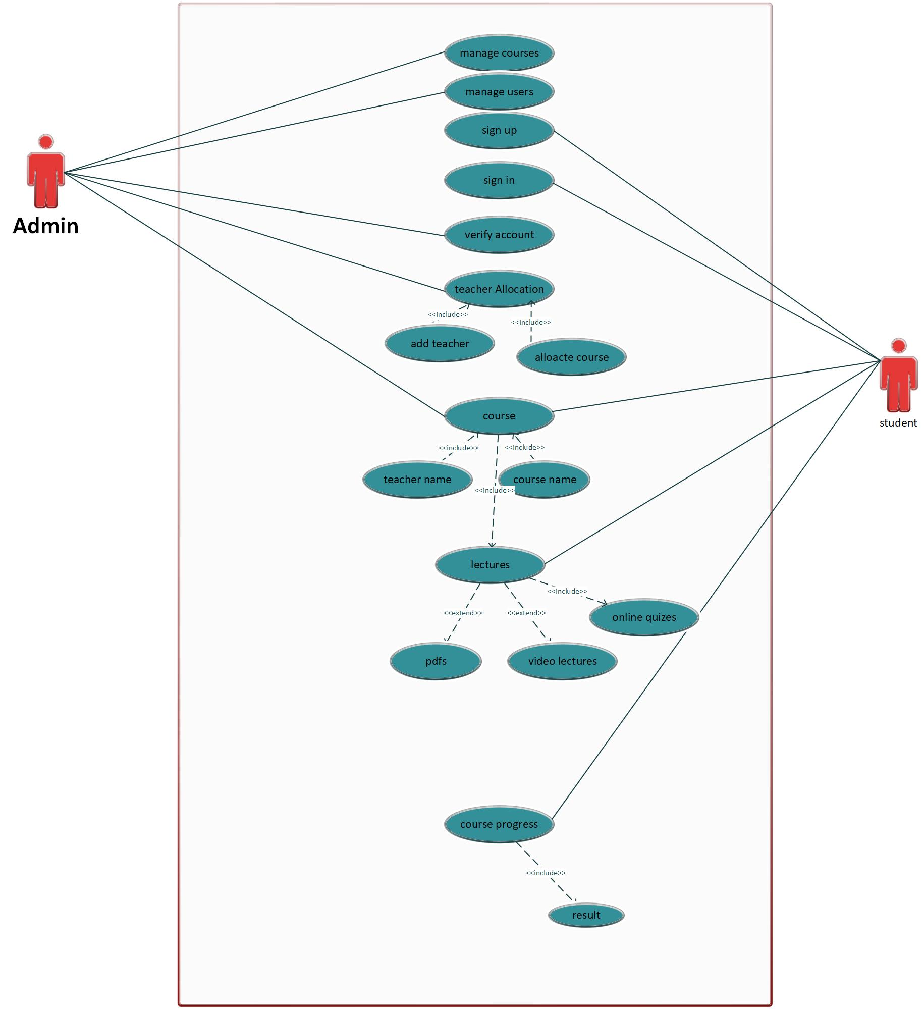

**Class Diagram:**

